Analog potentioimeter value

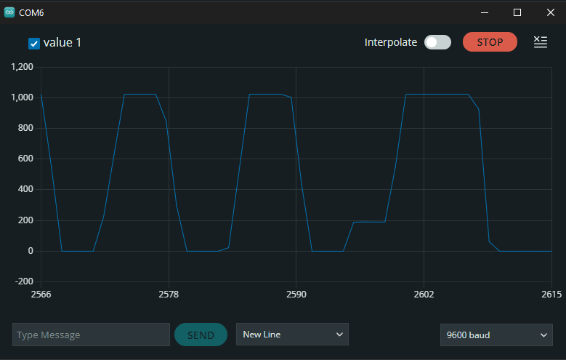

Scaled voltage

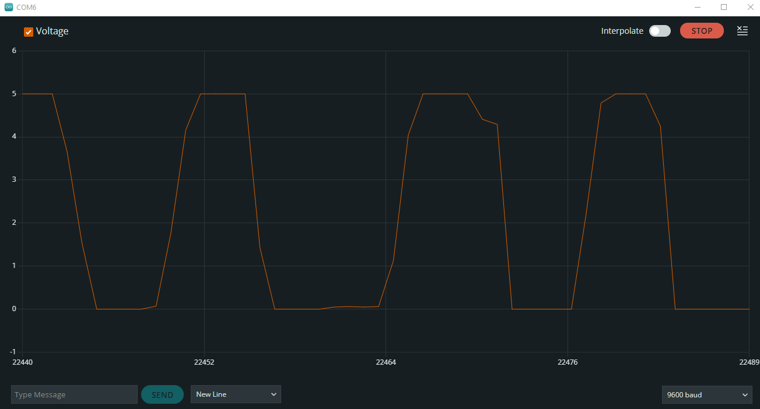

Led brightness:

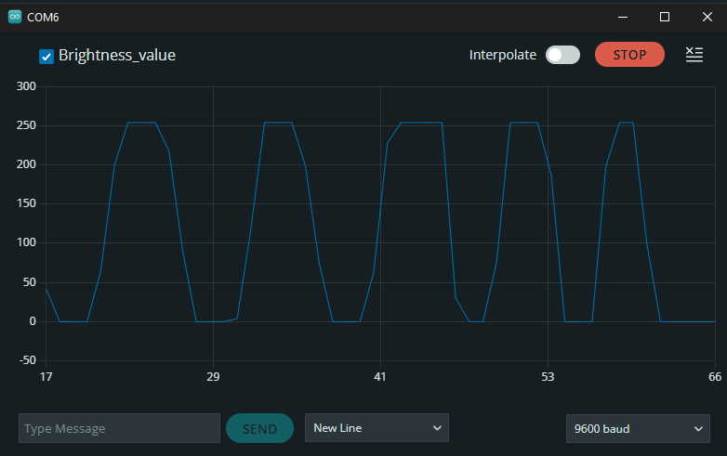

Plot distance:

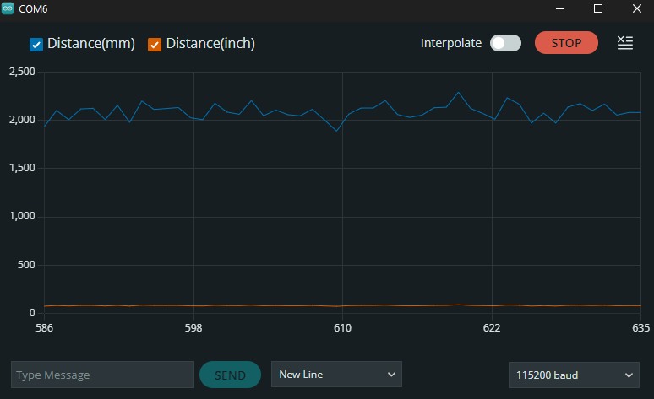

**Magnetic Encoder - Interrupts**

Review the code and check what it does.:

Manually rotate the wheel one rotation, based on the encoder reading and assuming that the code counts 12 pulses per revolution of the motor shaft, what is the gear ratio of the motor:

For one wheel rotation the value is 361

Rpm plot:

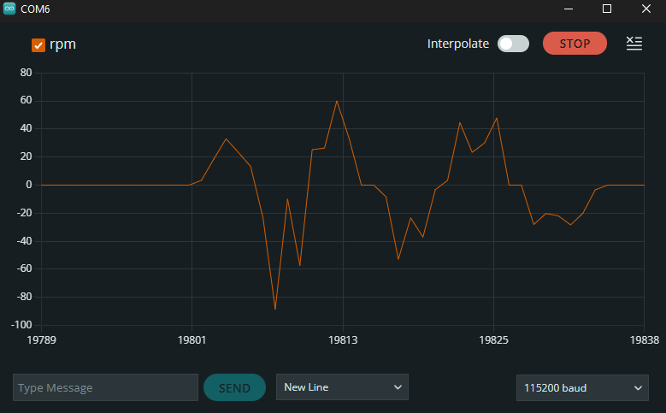

Rpm when controlled by potentiometer: